**Part I Mathematical Background**

**Linear Algebra**  
**Def: A vector is a collection of numbers in R. (or C, F)**Ex. $\overline{v}=\left({1 \atop 1}\right)$, $\overline{w}=\left({2 \atop 3}\right)$, $\overline{u}=(1, 4, 5)$  
 column vector row vector  
Throughout the semester, "vector" = "column vector", "vectorT" = "row vector",

Ex. ${\overline{v}}^{T}=(1, 1)$

**Def: Two operations:  
1.Vector addition: $\overline{v}+\overline{w}=\left({1 \atop 1}\right)+\left({2 \atop 3}\right)=\left({3 \atop 4}\right)$**   
**2.Scalar multiplication: For $c∈R$** , $d∈R$, $c\overline{v}=\left({c \atop c}\right)$**& $d\overline{w}=\left({2d \atop 3d}\right)$**   
Combining 1 & 2, we have a linear combination of vectors of vectors

$$c\overline{v}+d\overline{w}=\left({c \atop c}\right)+\left({2d \atop 3d}\right)=\left({c+2d \atop c+3d}\right)$$

**Def: The inner product of two vectors $\overline{v}=\left(\begin{aligned}v_{1} \\ v_{2} \\ . \\ . \\ v_{m}\end{aligned}\right)$ & $\overline{w}=\left(\begin{aligned}w_{1} \\ w_{2} \\ . \\ . \\ w_{m}\end{aligned}\right)$ is**

$$〈\overline{v}, \overline{w}〉={\overline{w}}^{T}∙\overline{v}=\sum_{i=1}^{m}{w_{i}∙v_{i}}$$

Ex. $<\overline{v}, \overline{w}> = {\overline{w}}^{T}∙\overline{v} = \left(2, 3\right)\left({1 \atop 1}\right)=2+3=5$

**Def: The Euclidean norm (L2-norm) of a vector $\overline{v}$ is $\left|\left|\overline{v}\right|\right|=\sqrt{〈\overline{v}, \overline{v}〉}=\sqrt{\sum_{i=1}^{m}{v_{i}^{2}}}$**

Ex. $\left|\left|\overline{w}\right|\right|=\sqrt{3^{2}+4^{2}}=5$

Geometrically, the norm of a vector represents the length of this vector.

Moreover, for two vectors $\overline{v}$& $\overline{w}$, $|\left|\overline{v}-\overline{w}\right||$ tells us the distance between these vectors. Ex. $\overline{v}=\left({1 \atop 1}\right) \overline{w}=\left({1 \atop 3}\right)$ $\left|\left|\overline{v}-\overline{w}\right|\right|=\left|\left|\left({1 \atop 1}\right)-\left({1 \atop 3}\right)\right|\right|=\left|\left|\left({0 \atop -2}\right)\right|\right|=2$

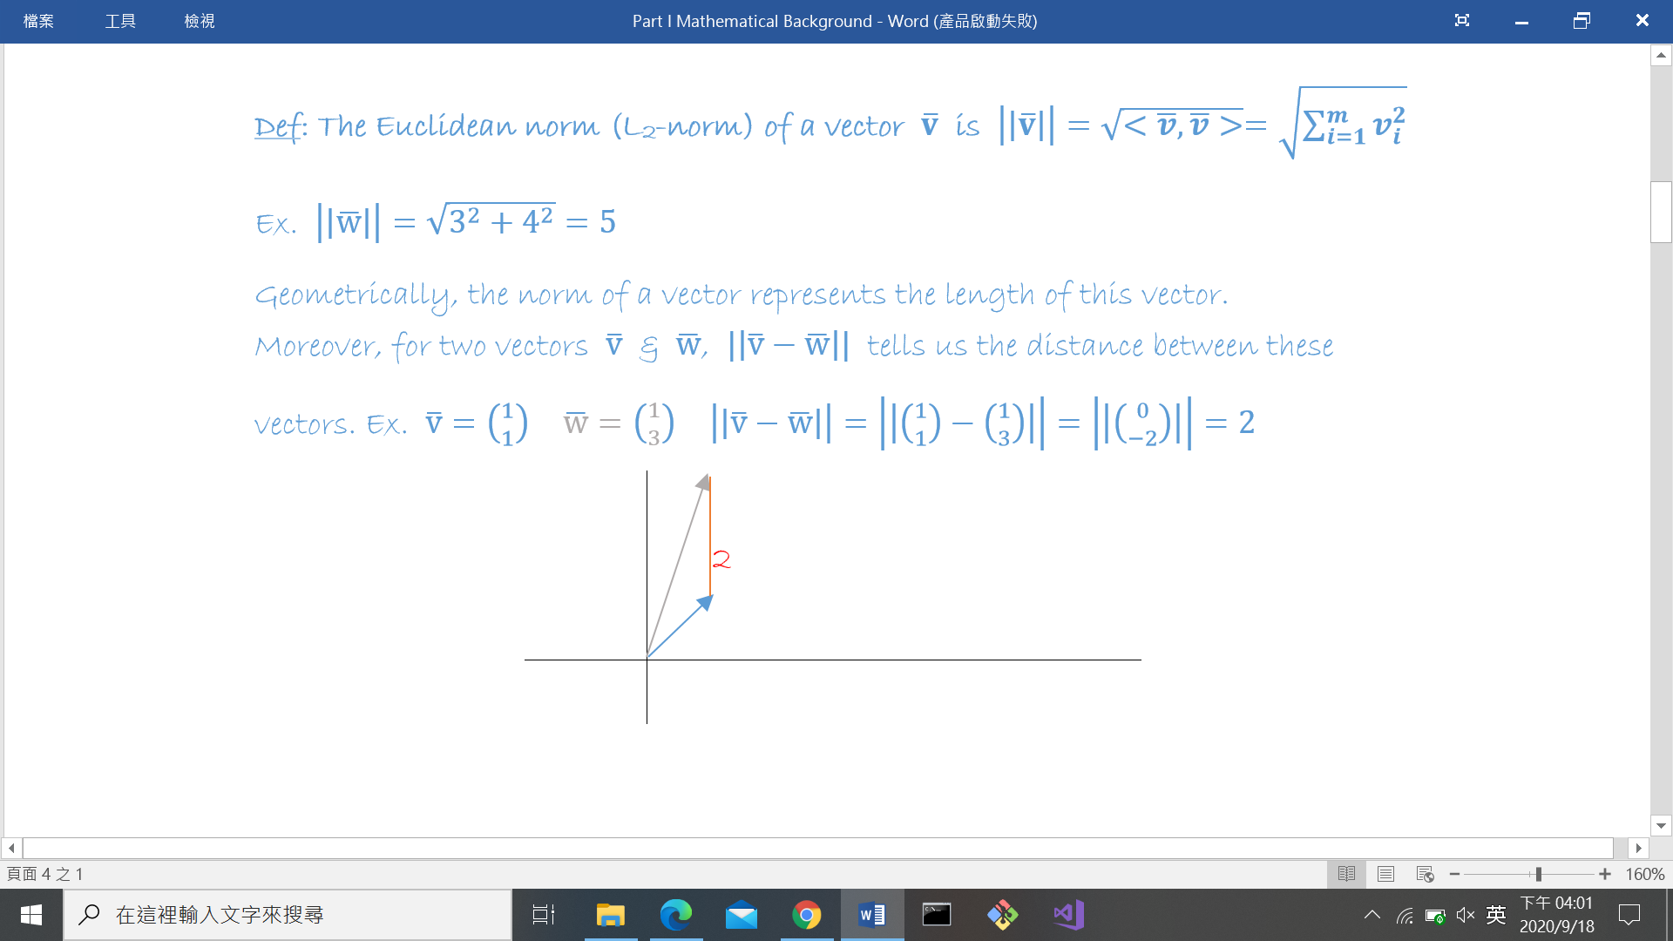

**Def: An $n×m$ matrix is rectangular array of values arranged into n rows and m columns.**

Ex.

$A=\left(\begin{aligned}1 2 3 \\ 1 1 1\end{aligned}\right)$, $B=\left(\begin{aligned}2 1 3 \\ 1 4 9\end{aligned}\right)$ are $2×3$ matrices, $C=\left(\begin{aligned}1 1 \\ 1 2 \\ 1 3\end{aligned}\right)$ is a $3×2$ matrix.

Two matrices with the **same dimension** can be added elementwise to form a new matrix.

$$A+B=\left(\begin{aligned}1 2 3 \\ 1 1 1\end{aligned}\right)+\left(\begin{aligned}2 1 3 \\ 1 4 9\end{aligned}\right)=\left(\begin{aligned}3 3 6 \\ 2 5 10\end{aligned}\right)$$

A (n $×$ m) and B (k $×$ p) can be multiplied into **AB** if and only if **m = k**, and can be multiplied into **BA** if and only if **p = n**.

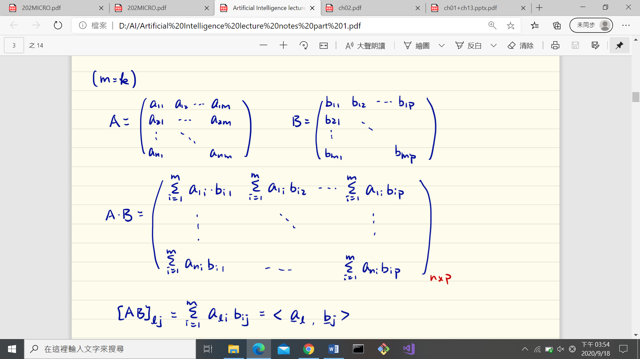

$${\left[AB\right]}_{ik}=\sum_{j=1}^{m}{a_{ij}b_{jk}}=〈\overline{a_{i}}, \overline{b_{k}}〉$$

where ${\overline{a_{i}}}^{T}$ is the ith row of $A$ and ${\overline{b_{k}}}^{T}$ is the kth column of $B$.

Ex. $A∙C=\left(\begin{aligned}1 2 3 \\ 1 1 1\end{aligned}\right)\left(\begin{aligned}1 1 \\ 1 2 \\ 1 3\end{aligned}\right)=\left({6 14 \atop 3 6}\right)$

Note that $BA≠AB$ in general. Multiplication of matrices does **NOT** satisfy **commutative** law. They even may not have the same dimensions.

**Def: The transpose of a matrix A is the matrix AT where the columns of AT are the rows of A.**

Ex. $A^{T}=\left(\begin{aligned}1 1 \\ 2 1 \\ 3 1\end{aligned}\right)$

**Def: The identity matrix is a square matrix ($n=m$) $I_{n}$ whose ${[I_{n}]}_{ij}=\left\{\begin{aligned}1, i=j \\ 0, i≠j\end{aligned}\right.$**

$I_{2}=\left({1 0 \atop 0 1}\right)$ $I_{3}=\left({\begin{aligned}1 0 0 \\ 0 1 0\end{aligned} \atop 0 0 1}\right)$ $AI=A$

**Def: A square matrix $A$ is said to be non-singular (invertible) if there exists a matrix $A^{-1}$ such that $A^{-1}A=AA^{-1}=I$. Otherwise, it is singular.**

Finding A-1 (if exists) can be done by **Gauss-Jordan elimination**, which involves complexity of **O(n3).**

Application: $A\overline{x}=b$, solve for $\overline{x}$.

$$A^{-1}\left(A\overline{x}\right)=A^{-1}b → Ix=A^{-1}b → x=A^{-1}b$$

**Probability**

**Def: A random variable (RV) is a function $X: Ω→R$**

**Ω: Sample space consisting of all the possible outcomes.**

Ex. Toss a coin, Ω = {Head, Tail}

Win $1 if the outcome is H

Lose $1 if the outcome is T

$$X(ω)=\left\{\begin{aligned} 1, if w=Head \\ -1, if w=Tail\end{aligned}\right.$$

**Def: An admissible subset of Ω is an event.**

Ex: Roll a die. Ω = {1, 2, 3, 4, 5, 6}

Event Big = {4, 5, 6} Small = {1, 2, 3}

**Def: For a countable Ω, a probability distribution called probability mass function (PMF) specifies the likelihood of any event. It assigns any $E⊆Ω$ a real number $P(E)∈[0, 1]$ such that**

**1) $P(E)≥0$ for every $E⊆Ω$**

**2) $P(Ω)=1$ (normalization)**

**3) For $E_{1}, E_{2}⊆Ω$ and $E_{1}∩E_{2}=\{∅\}$, $P(E_{1}∪E_{2})=P(E_{1})+P(E_{2})$**

**Def: Let $B$ be an event such that $P(B)>0$. A conditional probability distribution assigns to every event $A⊆Ω$ a number**

$P(A|B)=\frac{P(A∩B)}{P(B)}=\frac{P(A, B)}{P(B)}$

Ex. The die is fair. P(i) = 1/ 6 $∀$ I $∈$ {1, 2, 3, 4, 5, 6}

P(Big) = 1/2

P(4|Big) = (1/6) / (1/2) = 1/3

P(1|Big) = 0

**For uncountably infinite Ω (for example [a, b]) the probability of any particular point is 0. PMF is not well-defined.**

**Def: For a continuous RV X, the cumulative distribution function (CDF) is $F(x)=Pr(X≤x)$, which records the probability of X smaller than x.**

**If F(x) is differentiable, we can define the probability density function (PDF) as $f(x)=\frac{dF(t)}{dt}$ or $F(x)=\int_{-∞}^{x}{f\left(t\right)dt}$**

**Def: For a RV X, the expectation is defined as $E[x]=\sum_{i∈Ω}{x_{i}∙P(x_{i})}$ (1st moment), or $E[x]=\int_{-∞}^{∞}{x∙f\left(x\right)dx}$ (2nd moment), capturing the ensemble average of X.**

**The variance of X is defined as $var\left(X\right)=E{\left(X-E\left[X\right]\right)}^{2}=E\left[x^{2}\right]-E{[x]}^{2}$ measuring the spread of X out from $E[x]$.**

**Some frequently encountered RVs**

**Bernoulli: X~Bern(P)**

$Ω=\{0, 1\}$ $P\left(x=0\right)=1-P$ $P\left(x=1\right)=P$

$E\left[X\right]=P$ $variance=P-P^{2}=P(1-P)$